**Superstore Analysis Report**

**Executive Summary**

The analysis of the Superstore dataset reveals key insights into sales, profit, and performance trends across various dimensions, such as categories, regions, and periods. This report highlights the primary findings, offers actionable recommendations, and supports decisions to improve profitability and sales strategies.

**Insights**

**1. Sales by Category**

- Categories ranked by total sales:

- Top Performer: Technology (highest sales revenue).

- Furniture and Office Supplies follow, with moderate performance.

- High sales in Technology suggest a strong customer preference for this segment.

2. Profit Margins by Category

- Technology also leads to an average profit margin.

- Furniture and Office Supplies show relatively lower margins, suggesting potential inefficiencies or pricing challenges.

3. Regional Sales Performance

- Top Region: The western region outperformed the others in total sales.

- South and Central regions showed lower contributions to sales and profitability.

4. Sales Trends Over Time

- Yearly sales trends reveal consistent growth, with the highest sales in recent years.

- Monthly and quarterly data highlight seasonality, with spikes during Q4, likely due to holiday shopping trends.

5. Product-Level Insights

- High-Selling Products: Products in the Technology segment dominate.

- Underperformers: Several low-profit products in the Furniture category may need attention.

6. Discount and Pricing Strategy

- Heavy discounts negatively impact profit margins in certain segments.

- The calculated "Sales Before Discount" metric identifies opportunities to refine discounting strategies.

**Recommendations**

1. Optimize Pricing Strategies

- Reassess pricing and discount strategies for Furniture and Office Supplies to improve margins.

- Leverage the "Sales Before Discount" metric to evaluate the effectiveness of discount campaigns.

2. Focus on High-Performing Segments

- Invest in marketing and inventory for the Technology category to sustain growth.

- Identify high-margin products in other categories and promote them to improve profitability.

3. Regional Expansion and Targeting

- Develop targeted campaigns to boost sales in the South and Central regions.

- Explore regional preferences and adapt inventory and offerings accordingly.

4. Address Seasonal Trends

- Stock high-demand products and plan promotional campaigns for Q4 to capitalize on the holiday season.

- Smooth sales fluctuations by introducing mid-year promotions.

5. Streamline Underperforming Products

- Evaluate low-profit items for discontinuation or improvement.

- Negotiate better supplier rates or reduce costs for these products.

**Visualizations**

1. Top 10 Product

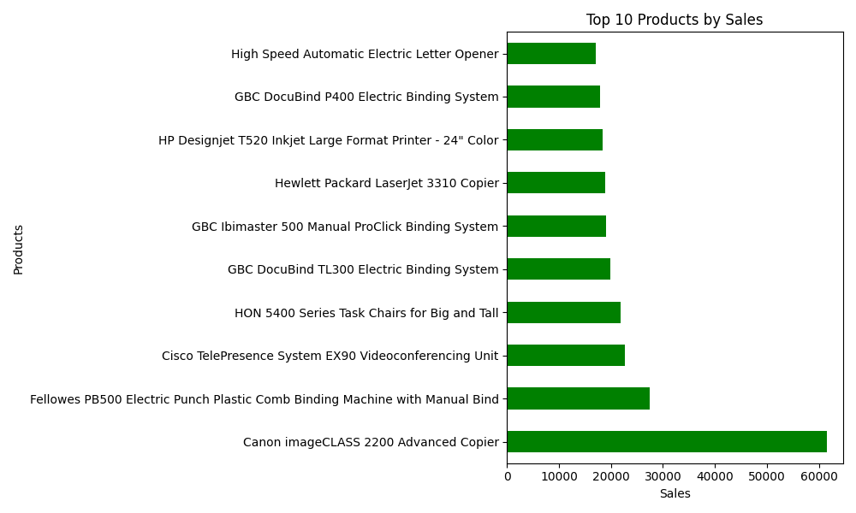

2. Top 10 State by Profit

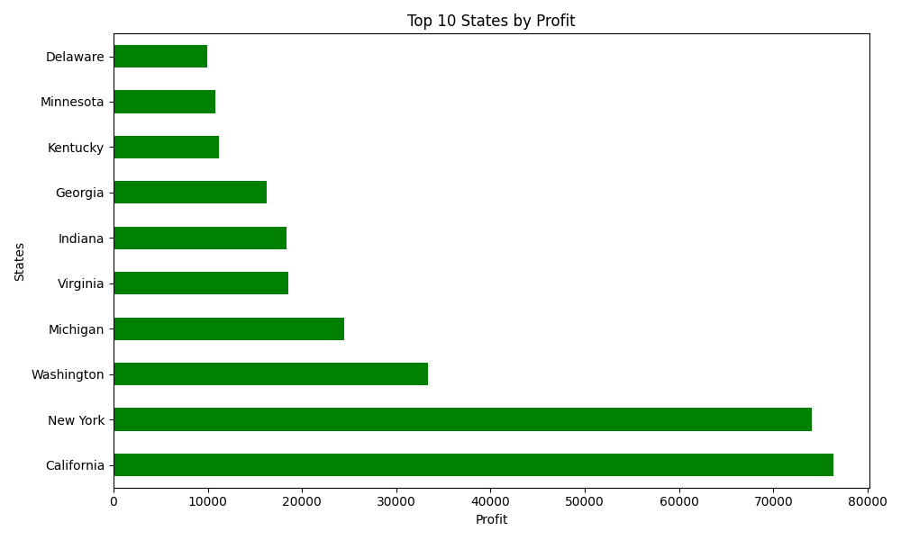

3. Sales by Category

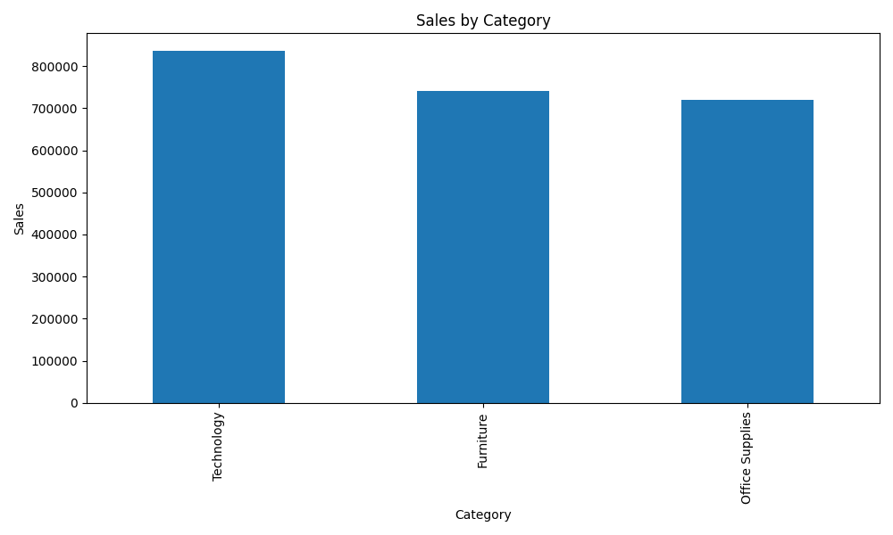

4. Average Profit Margin by Category

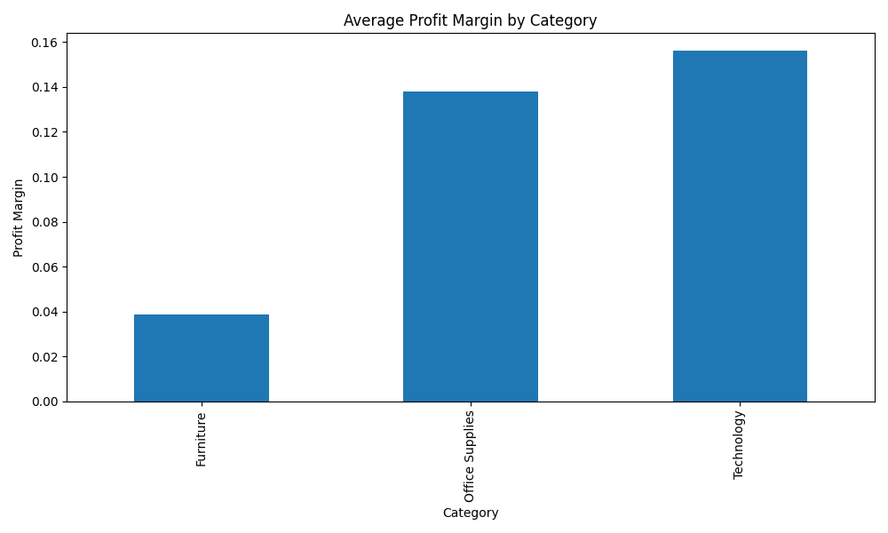

5. Yearly Sales Trend

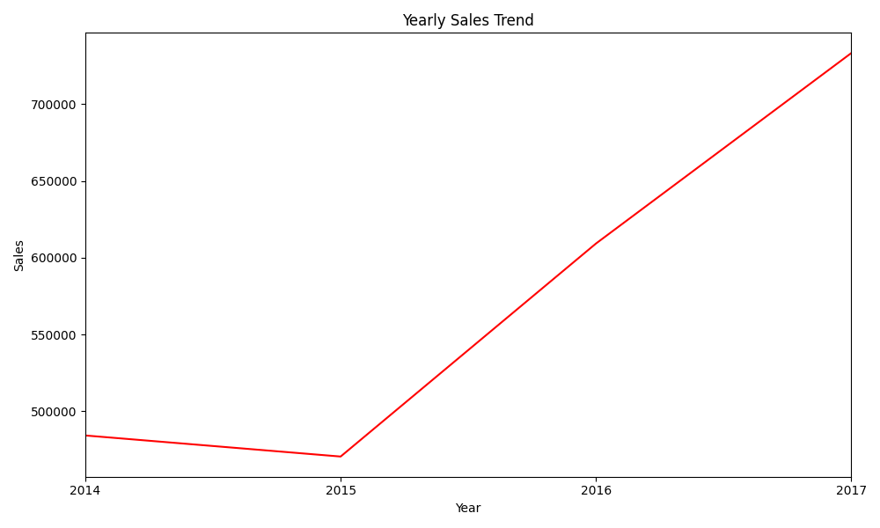

6. Profit by Discount

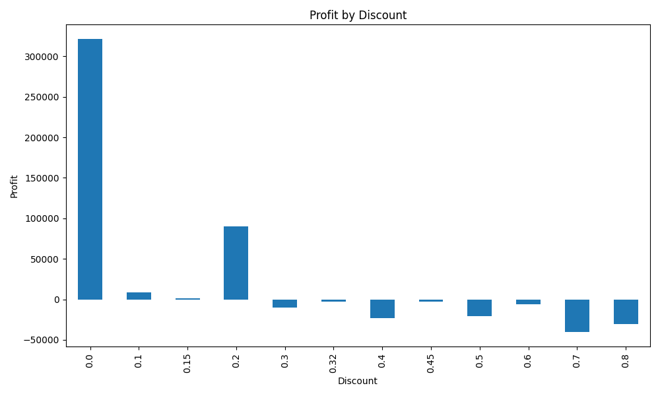

7. Highest Demand Category

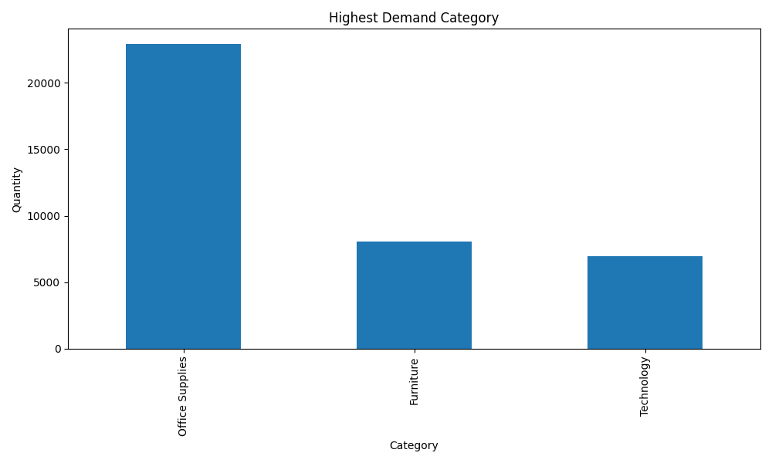

**Conclusion**

This analysis highlights critical areas for improvement and growth opportunities. By implementing the recommended strategies, Superstore can enhance its profitability and maintain its competitive edge in the market.